Question 1 : Design the below using HTML, ( CSS or Bootstrap )

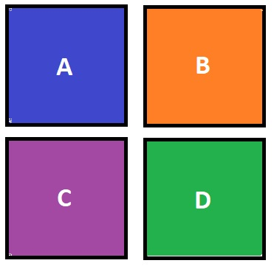

Instructions :

* Border of each box should be 5px.
* The alphabets should be in the middle of their respective boxes.

Question 2 : Design the below using HTML, ( CSS or Bootstrap )



Instructions :

* You can use any image in place of the icons.

Question 3 : Design the below using HTML, ( CSS or Bootstrap ). You can use jQuery for the dropdown mechanism.

